**Soarian to Availity ADT**

**Version 1.0**

**Prepared By: Cliff Patton**

**Date: 5/6/2015**

Document Control 3

Resources 3

Project Distribution List 3

Document Version Control 3

1. Introduction 4

1.1 Purpose 4

1.2 Project Scope 4

1.3 Terminology Standards 4

1.3.1 Acronyms 4

1.3.2 Glossary 4

1.4 Document References 4

2. Diagram 5

3. Requirements 5

3.1 Functional Requirements 5

3.2 Non-Functional Requirements 5

3.3 Messaging Protocols 6

3.3.1 Inbound to the BayCare Cloverleaf 6

3.3.2 Outbound from the BayCare Cloverleaf 6

3.3.3 Inbound to the BayCare Cloverleaf 6

3.3.4 Outbound from the BayCare Cloverleaf 7

4. HL7 Messaging 8

4.1 Messaging Format 8

4.1.1 Segments 8

4.1*.*2 Messaging Event Types 9

4.1*.*3 Cloverleaf Configuration Files 9

4.1.4 Cloverleaf Site Location 9

4.2 Data Transformation Requirements 10

4.3 Sample Message 14

5. Testing 14

5.1. Unit Testing Scenarios 14

5.2 Integrated Testing Scenarios 15

5.3 Testing Approvals 15

5.4 Piloting 15

5.5 Approvals 15

6. Deployment / Implementation Model 16

Appendix A: Risks and Concerns 16

Appendix B: Issues List 16

# **Document Control**

## Resources

|  |  |  |
| --- | --- | --- |
| **Name** | **Role** | **Email** |
| Art Schwartz | BayCare Integration Analyst - Cloverleaf | [Art.Schwartz@baycare.org](mailto:Art.Schwartz@baycare.org) |
|  |  |  |
|  |  |  |
|  |  |  |
|  |  |  |
|  |  |  |
|  |  |  |
|  |  |  |

## Project Distribution List

## Document Version Control

|  |  |  |  |
| --- | --- | --- | --- |
| **Version** | **Date** | **Modifier** | **Description** |
| V1.0 | 5/5/2015 | Cliff Patton | Originally Created |
|  |  |  |  |
|  |  |  |  |
|  |  |  |  |

# 1. Introduction

## 1.1 Purpose

This document will define the communication protocol, message structure, and special business logic for the ADT Soarian to Availity interfaces. This document will be used to complete the build and to denote all changes to the initial requirements. The intended audience is developers and business owners.

## 1.2 Project Scope

This interface will facilitate the automation of the filing insurance authorizations to payers contracted with both BayCare and Availity. This interface will send qualified patient accounts with insurances from Blue Cross, Humana and Etna

## 1.3 Terminology Standards

### 1.3.1 Acronyms

BCBSFL Blue Cross/Blue Shield - Florida

LPI Local Provider Identifier

NPI National Provider Identifier

### 1.3.2 Glossary

## 1.4 Document References

# 2. Diagram

# 3. Requirements

## 3.1 Functional Requirements

Provide detail for the below functional requirements. The message transformation requirements for the components defined in this specification should be specified in section 4.2 of this document.

|  |  |  |
| --- | --- | --- |
| **Cloverleaf** |  |  |
| **Number** | **Requirement Name** | **Requirement Description** |
| FR.2015.5.0 | Availity only needs patient types requiring authorizations | Cloverleaf filters old discharges and only allows transactions for inpatients and observation outpatients. |
| FR.2015.5.1 | Qualified Payer | Cloverleaf filters transactions for qualifying patient types that nave no insurance payer serviced by Availity for BayCare. |
| FR.2015.5.2 | Availity requires an ID code unique to each payer | Upon determining valid payer, Cloverleaf defines receiving application. |
| FR.2015.5.0  FR.2018.3.0 | Payer requires NPI.  Valid Insurance | Cloverleaf must include the identifier “NPI” in PV1:7.13.  *This interface will send qualified patient accounts with insurances from Blue Cross, Humana and Etna* To go to Availity the insurance plan must be in the valid insurance tables. Avail_other_ins for all non-Blue cross. All insurances must be in the BC_plan_code table. Blue cross must also have a valid policy number. A BC policy number is valid if it meets any of the following criteria;   1. the 4th character is “H” and the 5th character is numeric, 2. 2 –the first character is “R” or “H”and the second character is numeric 3. The first 3 characters are in the bc_policy_number_prefix table. |

## 3.2 Non-Functional Requirements

Provide concise detail for the below non-functional requirements. The below requirements must be evaluated for every project.

|  |  |  |
| --- | --- | --- |
| **Cloverleaf** |  |  |
| **Number** | **Requirement Name** | **Requirement Description** |
| NFR.20XX.1.0 | Click here to enter text. | Click here to enter text. |

## 3.3 Messaging Protocols

Below are listed the details for the messaging protocols that will be leveraged for this integration.

### 3.3.1 Inbound to the BayCare Cloverleaf

* TCP MLLP

### 3.3.2 Outbound from the BayCare Cloverleaf

* TCP MLLP

### 3.3.3 Inbound to the BayCare Cloverleaf

Test

MPH/NBY

Port Number: 20002

IP Address: 10.5.250.203

MCS/MDU

Port Number: 20010

IP Address: 10.5.250.203

SFB/SAH

Port Number: 20004

IP Address: 10.5.250.203

SJH/SJW

Port Number: 20003

IP Address: 10.5.250.203

SJN/SJS

Port Number: 20006

IP Address: 10.5.250.203

WHH/WHW

Port Number: 20009

IP Address: 10.5.250.203

Prod

MPH/NBY

Port Number: 20002

IP Address: 10.5.250.201

MCS/MDU

Port Number: 20010

IP Address: 10.5.250.201

SFB/SAH

Port Number: 20004

IP Address: 10.5.250.201

SJH/SJW

Port Number: 20003

IP Address: 10.5.250.201

SJN/SJS

Port Number: 20006

IP Address: 10.5.250.201

WHH/WHW

Port Number: 20009

IP Address: 10.5.250.201

### 3.3.4 Outbound from the BayCare Cloverleaf

Test

Port Number: 2575

IP Address: 199.116.187.68

Prod

Port Number: 2575

IP Address: 199.116.188.68

# 4. HL7 Messaging

## 4.1 Messaging Format

### 4.1.1 Segments

#### 4.1.1.1 Inbound Segments

The segments utilized for this interface are:

MSH

EVN

PID

[PV1]

[PV2]

[{DG1}]

[{

IN1

}]

#### 4.1.1.2 Outbound Segments

The segments utilized for this interface are:

MSH

EVN

PID

[PV1]

[{DG1}]

[{PR1}]

[{

IN1

}]

*Message Construction Notes:*

*Control Characters:*

*[Square Brackets] – Optional*

*{Curly Brackets} – Repeatable*

*[{ – Start of optional, repeatable group*

*}] – End of optional, repeatable group*

*Segment Definitions*

*MSH – Message Header*

*EVN – Event Segment*

*PID – Patient ID Segment*

*PV1 – Patient Visit Segment*

*PV2 – Patient Visit Segment*

*DG1 – Diagnosis Segment*

*PR1 – Procedures Segment*

*IN1 – Insurance Segment*

### 4.1*.*2 Messaging Event Types

Below are the messages types necessary for this integration

|  |  |
| --- | --- |
| **Event Type** | **Description** |
| ADT^A01 | Patient Admit |
| ADT^A02 | Patient Transfer |
| ADT^A03 | Patient Discharge |
| ADT^A04 | Patient Registration |
| ADT^A06 | Change Outpatient to Inpatient |
| ADT^A07 | Change Inpatient to Outpatient |
| ADT^A08 | Update Patient Information |
| ADT^A09 | Patient Departing |
| ADT^A10 | Patient Arriving |
| ADT^A11 | Cancel Admission |
| ADT^A13 | Cancel Discharge |
| ADT^A28 | Add Person Information |
| ADT^A31 | Update Person Information |
| ADT^A32 | Cancel Patient Arriving |
| ADT^A33 | Cancel Patient Departing |
| ADT^A34 | Merge Patient Information. |

### 4.1*.*3 Cloverleaf Configuration Files

HL7 Variant: 2.6 Soarian

2. 6 Soarian

### 4.1.4 Cloverleaf Site Location

* soarf_adt_ent_18

## 4.2 Data Transformation Requirements

| **Field Description** | **HL7 Field Loc.** | **Required Y/N** | **Data Type** | **Length** | **Notes** |
| --- | --- | --- | --- | --- | --- |
| MSH |  |  |  |  |  |
| Field separator | MSH:1 | Y |  |  | Default “|” |
| Encoding characters | MSH:2 | Y |  |  | Literal “^~&\” |
| Sending Application | MSH:3 |  |  |  | MSH:4 |
| Sending Facility | MSH:4.1 |  |  |  | Literal “BAYCARE” |
|  | MSH:4.2 |  |  |  | Literal “252405” for test  Literal “8168” for prod |
| Receiving Application | MSH:5 |  |  |  | Literal “00590” for BCBSFL  Literal “61101” for Humana |
| Receiving Facility | MSH:6 |  |  |  | Literal “AVAILITY” |
| Date/Time Of Message | MSH:7 |  |  |  | MSH:7 |
| Message Type | MSH:9 | Y |  |  | MSH:9 |
| Message Control ID | MSH:10 | Y |  |  | MSH:10 appended with system generated unique value |
| Processing ID | MSH:11 | Y |  |  | Literal “P” |
| Version ID | MSH:12 | Y |  |  | Default “2.3” |
| Continuation Pointer | MSH:14 | Y |  |  | MSH:10 truncate to 12 characters |
| EVN |  |  |  |  |  |
| Event Type Code | EVN:1 |  |  |  | EVN:1 |
| Recorded Date/Time | EVN:2 | Y |  |  | EVN:2 |
| Operator ID | EVN:5 |  |  |  | EVN:5 |
| PID |  |  |  |  |  |
| Set ID - Patient ID | PID:1 |  |  |  | PID:1 |
| Patient ID (Internal ID) | PID:3.1 | Y |  |  | PID:3.1 |
|  | PID:3.4 | Y |  |  | Literal “MR” |
| Patient Name | PID:5 | Y |  |  | PID:5 |
| Date/Time of Birth | PID:7 |  |  |  | PID:7 |
| Sex | PID:8 |  |  |  | PID:8 |
| Race | PID:10 |  |  |  | PID:10, table soarf_inv_race.tbl |
| Patient Address | PID:11 |  |  |  | PID:11 |
| Phone Number - Home | PID:13.1 |  |  |  | If PID:13.2 is “PRN”, concatenate and reformat PID:13.6 and PID:13. 7 |
|  | PID:13.2 |  |  |  | If PID:13.2 is “PRN”, map PID:13.2 |
| Primary Language | PID:15 |  |  |  | PID:15, table soarf_inv_language.tbl |
| Marital Status | PID:16 |  |  |  | PID:16, table sms_avail_marital.tbl |
| Religion | PID:17 |  |  |  | PID:17, table soarf_inv_religion.tbl |
| Patient Account Number | PID:18 |  |  |  | PID:3.1 where PID:3.5 is “PN” |
| SSN Number - Patient | PID:19 |  |  |  | PID:19 |
| PV1 |  |  |  |  |  |
| Set ID - PV1 | PV1:1 |  |  |  | PV1:1 |
| Patient Class | PV1:2 | Y |  |  | PV1:2 |
| Assigned Patient Location | PV1:3 |  |  |  | PV1:3 |
| Admission Type | PV1:4 |  |  |  | PV1:4, table soarf_avail_admit_type.tbl |
| Attending Doctor | PV1:7.1 |  |  |  | PV1:7.7 |
|  | PV1:7.2 |  |  |  | PV1:7.2 |
|  | PV1:7.3 |  |  |  | PV1:7.3 |
|  | PV1:7.13 |  |  |  | Literal “NPI” |
| Hospital Service | PV1:10 |  |  |  | PV1:10, if “OBS”, literal “MAT” else literal “MED” |
| Admit Source | PV1:14 |  |  |  | PV1:14, table avail_admit_source.tbl |
| VIP Indicator | PV1:16 |  |  |  | PV1:16 |
| Patient Type | PV1:18 |  |  |  | PV1:18 |
| Delete Account Date | PV1:35 |  |  |  | If MSH:9.2 is “A08”, map from PV1:45 before final processing evaluation for discharges. See PV1:45 below |
| Discharge Disposition | PV1:36 |  |  |  | PV1:36, table sms_avail_disch_disp.tbl |
| Admit Date/Time | PV1:44 |  |  |  | PV1:44 |
| Discharge Date/Time | PV1:45 |  |  |  | If EVN:1 is “A09”, then map from EVN:2.1, else map from PV1:45  If MSH:9.2 is “A09” and PV1:2 is IP, then map from PV1:44  (PREVIOUS VALUES ARE USED TO VALUE PV1:35 THEN COMPLETES PROCESSING BELOW)  If MSH:9.2 is not “A09” and not “A03”, then map from {null} |
| DG1 |  |  |  |  |  |
| Set ID - DG1 | DG1:1 | Y |  |  | DG1:1 |
| Diagnosis Coding Method | DG1:2 |  |  |  | DG1:2 |
| Diagnosis Code | DG1:3 |  |  |  | DG1:3 |
| Diagnosis Type | DG1:6.1 | Y |  |  | DG1:6.1, table sms_avail_diag_type.tbl |
| PR1 |  |  |  |  | If 3 char truncated PV2:40 = “Obs” |
| Set ID - PR1 | DG1:1 | Y |  |  | Literal “1” |
| Procedure Code | DG1:3.1 | Y |  |  | Literal “0761” |
|  | DG1:3.2 |  |  |  | Literal “OBS” |
|  | DG1:3.3 |  |  |  | Literal “NUBC” |
| Procedure Date/Time | DG1:5 | Y |  |  | PV1:44 |
| Procedure Type | DG1:6.1 | Y |  |  | Literal “D” |
| IN1 |  |  |  |  | If MSH:9.2 defined to require IN1 from table valid_IN1.tbl  If qualifying payer (Currently BCBSFL, Humana) and not A03 |
| Set ID - IN1 | IN1:1 | Y |  |  | IN1:1 |
| Insurance Plan ID | IN1:2 | Y |  |  | IN1:2 |
| Insurance Company ID | IN1:3 | Y |  |  | BCBSFL = Literal “00590”  Humana = Literal “61101”  Other = “X” |
| Insurance Company Name | IN1:4 |  |  |  | IN1:4 |
| Insurance Company Address | IN1:5 |  |  |  | IN1:5 |
| Insurance Co Phone Number | IN1:7 |  |  |  | IN1:7 |
| Insured’s Group Emp Name | IN1:11 |  |  |  | IN1:11 |
| Authorization Information | IN1:14 |  |  |  | IN1:14 |
| Plan Type | IN1:15 |  |  |  | IN1:15 truncated to 3 char |
| Name Of Insured | IN1:16 |  |  |  | IN1:16 |
| Insured’s Relationship To Patient | IN1:17 |  |  |  | IN1:17 |
| Insured’s Date Of Birth | IN1:18 |  |  |  | IN1:18 |
| Coord Of Ben. Priority | IN1:22 |  |  |  | IN1:22 |
| Verification By | IN1:30 |  |  |  | IN1:30 |
| Policy Number | IN1:36 |  |  |  | IN1:36 |
| Insured’s Sex | IN1:43 |  |  |  | IN1:43 |
| Verification Status | IN1:45 |  |  |  | IN1:45, truncate to 2 char |
| Coverage Type | IN1:47 |  |  |  | Literal “H” |
|  |  |  |  |  |  |

## 4.3 Sample Message

# **5. Testing**

## 5.1. Unit Testing Scenarios

|  |  |
| --- | --- |
| **Scenario** | **Expected Result** |
|  |  |
|  |  |
|  |  |
|  |  |
|  |  |

## 5.2 Integrated Testing Scenarios

|  |  |
| --- | --- |
| **Scenario** | **Expected Result** |
|  |  |
|  |  |
|  |  |
|  |  |
|  |  |
|  |  |

## 5.3 Testing Approvals

|  |  |  |  |
| --- | --- | --- | --- |
| **Testing Phase** | **Date** | **Department** | **Team Member** |
| PH1.UNIT |  |  |  |
| PH1.INTEGRATED |  |  |  |

### 

## 5.4 Piloting

List the facilities and associated networks in scope for pilot testing.

## 5.5 Approvals

|  |  |  |  |
| --- | --- | --- | --- |
| **Testing Phase** | **Date** | **Department** | **Team Member** |
| PH1.0 |  |  |  |
|  |  |  |  |
|  |  |  |  |

# 6. Deployment / Implementation Model

Provide the detail as to how to deploy the solution defined in the IDBB from both the BAYCARE and vendor perspective.

# 7. Tables

Avail_other_ins

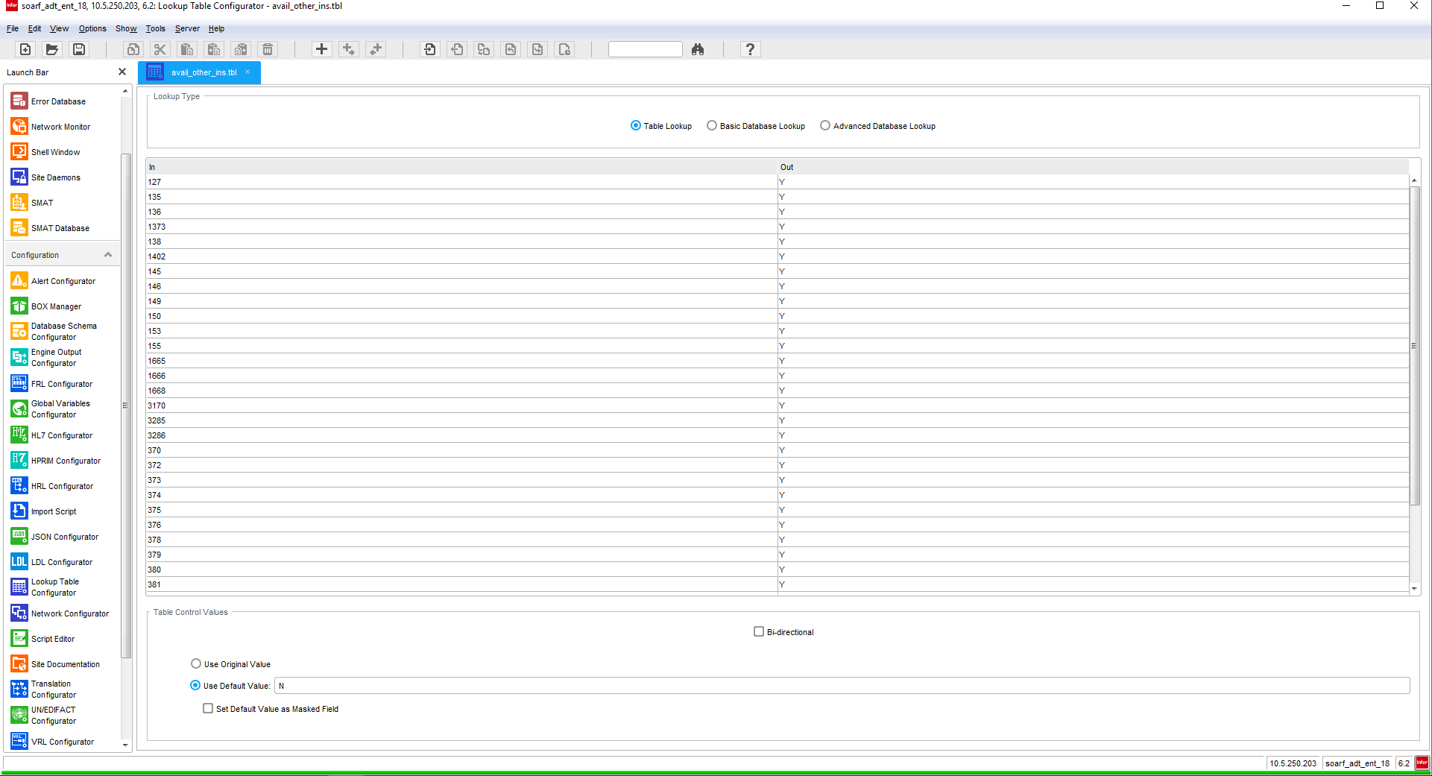

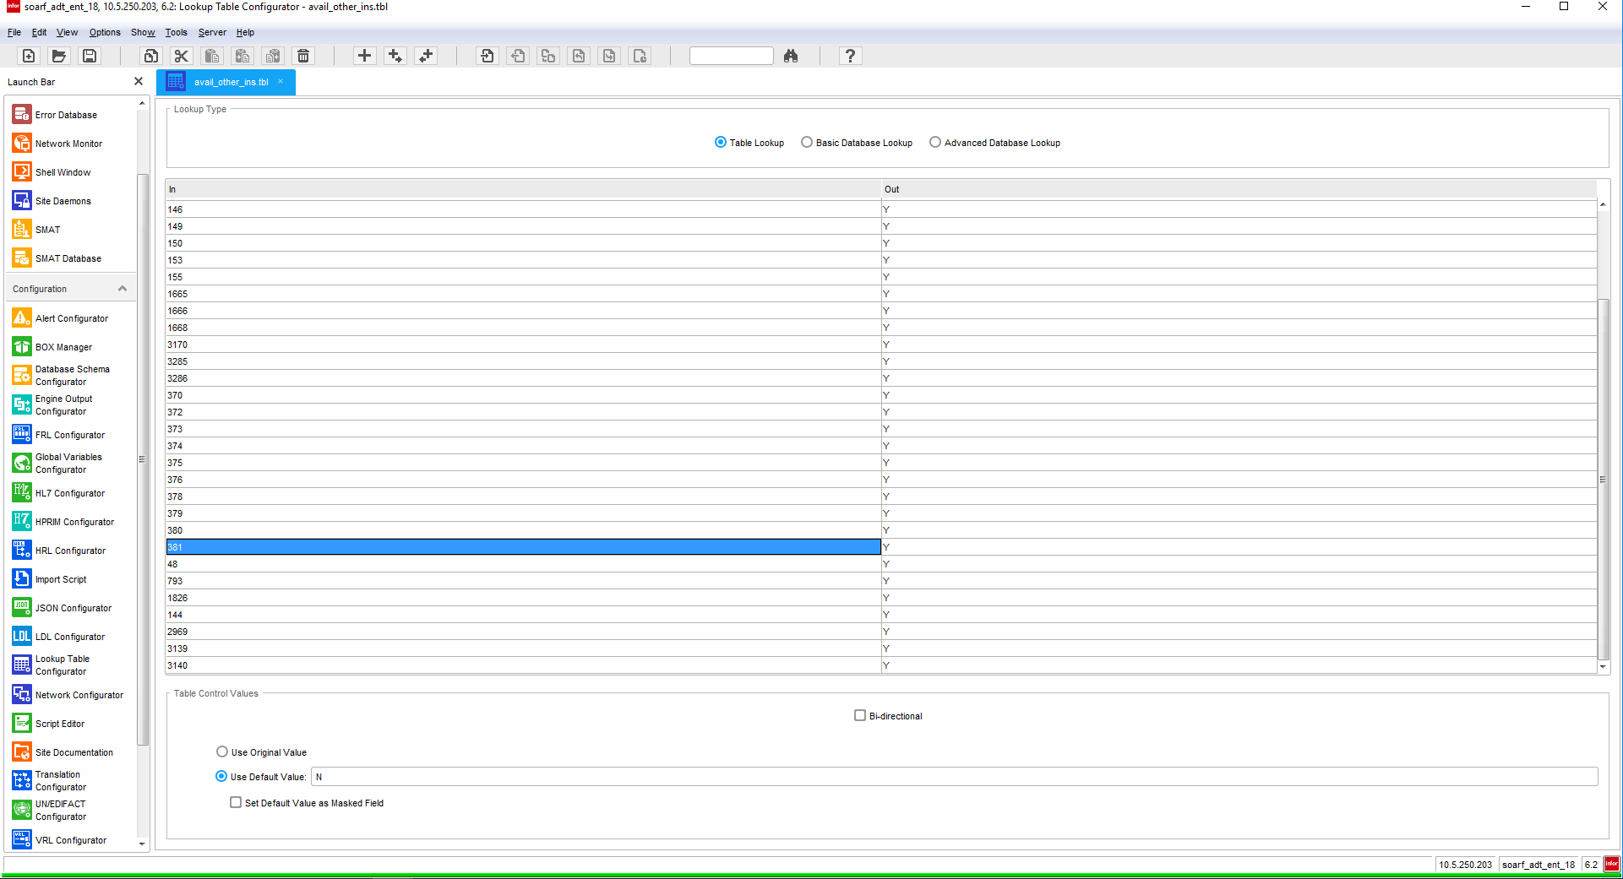

BC_plan_codes

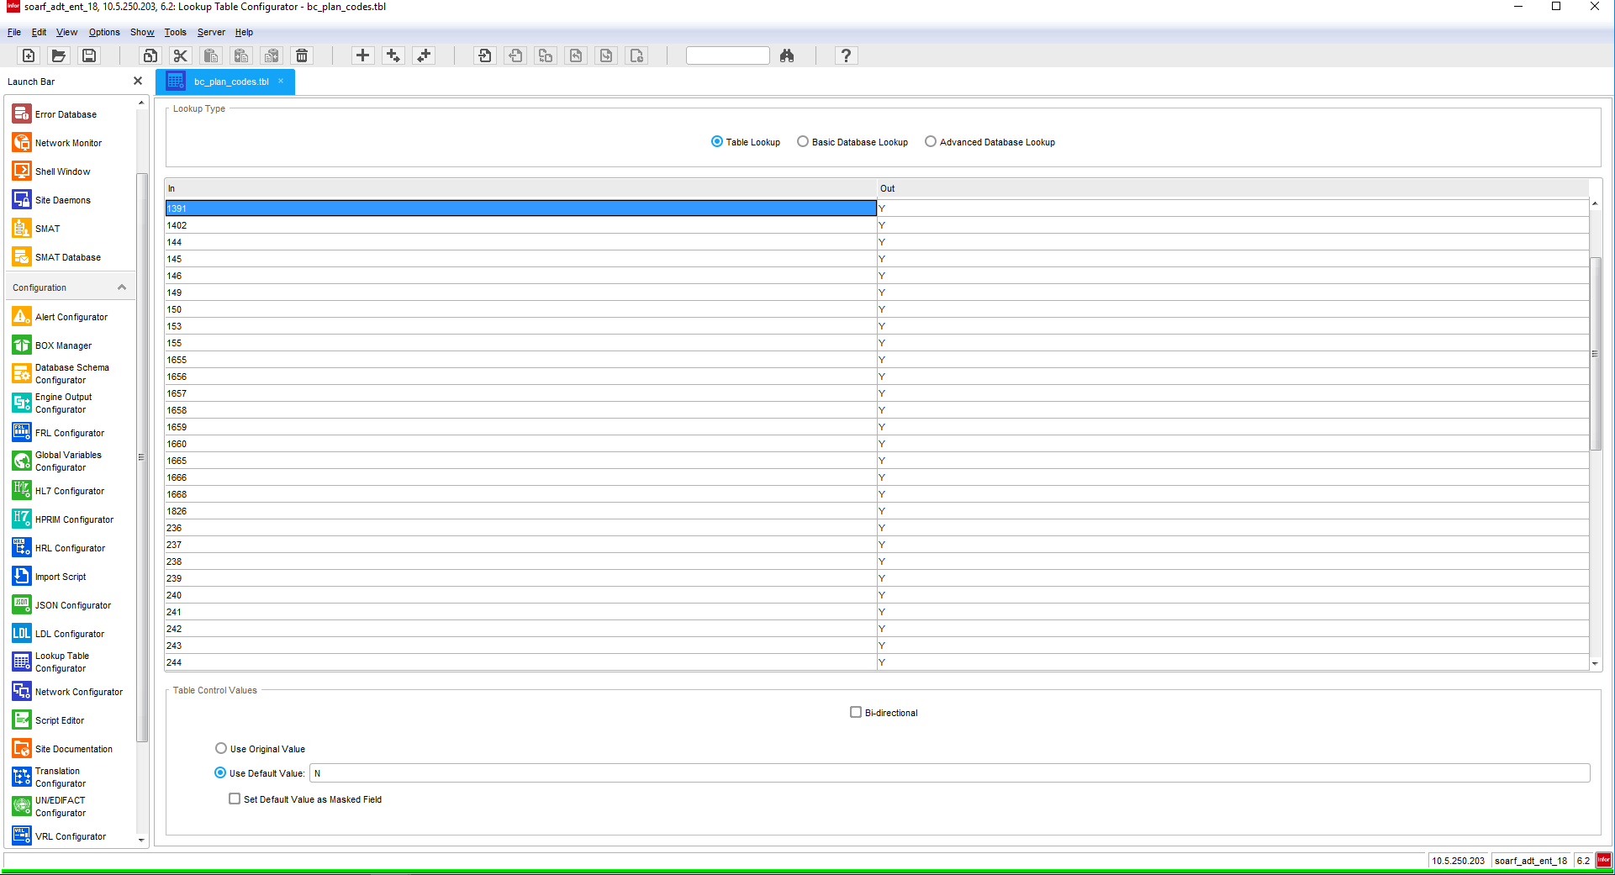

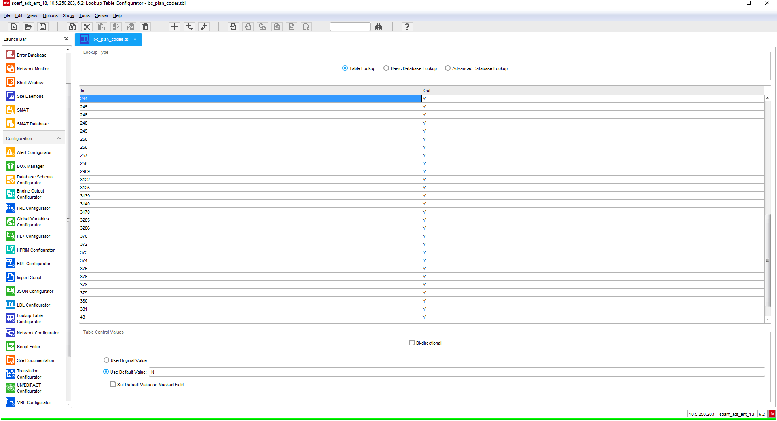

# 

# BC_policy_number_prefix

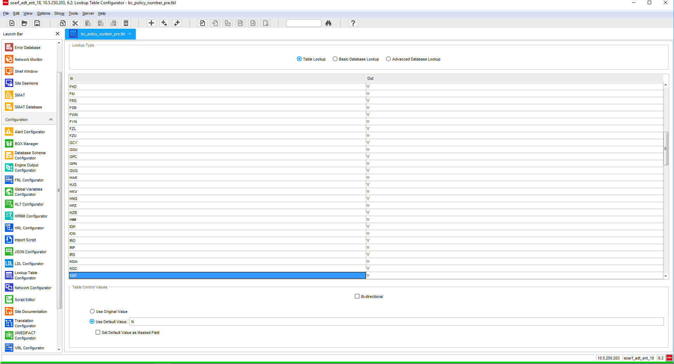

# 

# 

# 

# 

# Appendix A: Risks and Concerns

|  |  |  |  |  |  |  |  |  |
| --- | --- | --- | --- | --- | --- | --- | --- | --- |
| **Project Name** |  |  | | |  |  |  |  |
| **Number** | **Risk / Concern** | **Comment** | **Mitigation** | | |  |  |  |
| RC.2013.1.0 |  |  | |  | |  |  |  |

# Appendix B: Issues List

This is a dynamic list of the open issues related to the IDBB that remain to be solved, including but not limited to TBDs, pending decisions, information needed, conflict awaiting resolution, and the like.

|  |  |  |  |  |  |  |  |  |
| --- | --- | --- | --- | --- | --- | --- | --- | --- |
| **Project Name** |  |  | | |  |  |  |  |
| **Number** | **Issue** | **Comment** | **Fix** | | |  |  |  |
| I.2013.1.0 |  |  | |  | |  |  |  |

* End of document